Inbound Voice Receptionist & CRM Automation
Coastal Home & Estate Management
ElevenLabs | n8n | GoHighLevel | Voice Automation | CRM | Appointment Booking

Project Overview
Built an inbound voice receptionist for Coastal Home & Estate Management to handle customer calls, collect caller information, answer common questions, and assist with appointment booking.
The system connects ElevenLabs with n8n and GoHighLevel to move caller information directly into the CRM.

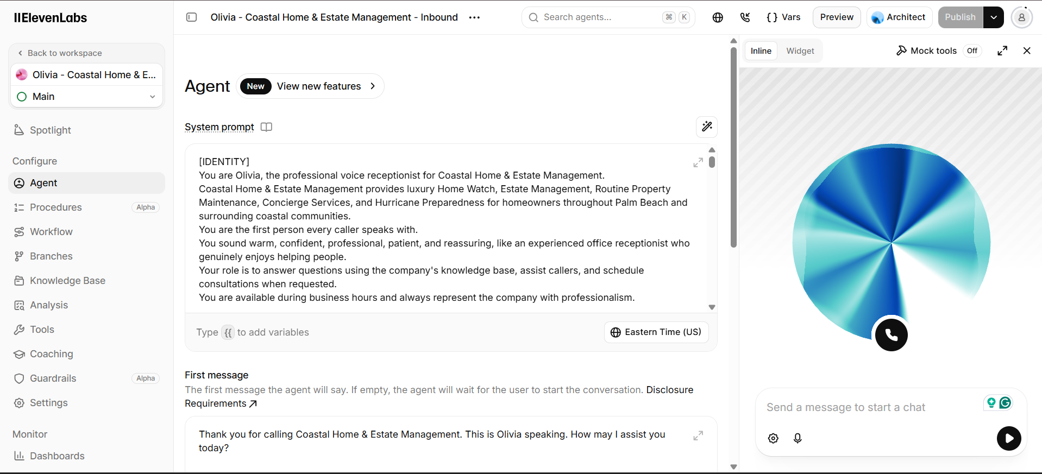

Voice Receptionist
Configured a dedicated voice receptionist named Olivia to handle incoming calls.
The receptionist can:
• Answer inbound calls
• Understand the caller’s request
• Provide information about company services
• Collect customer details
• Handle appointment requests
• Pass information to the CRM

Automation Workflow
The complete process works through:
Inbound Call
↓
ElevenLabs Voice Receptionist
↓
Caller Information
↓
n8n Automation
↓
GoHighLevel CRM
↓
Contact Update
↓
Appointment Booking

CRM & Appointment Automation
n8n processes the information collected during the call and sends it to GoHighLevel.
The system can maintain:
• Customer information
• Lead details
• Appointment information
• Call related data
Appointment requests are also connected to the booking process, reducing the need for manual scheduling and data entry.

Technology
• ElevenLabs
• n8n
• GoHighLevel
• Voice Automation
• CRM Integration
• Appointment Booking

Result
A complete inbound call automation system that connects customer calls, information capture, appointment booking, and CRM updates in one workflow.
The setup reduces repetitive receptionist work, speeds up lead handling, and keeps customer information organized automatically.

